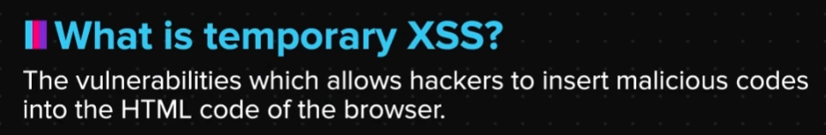

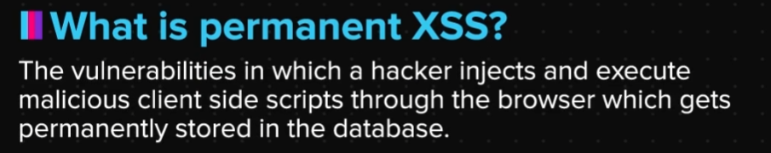

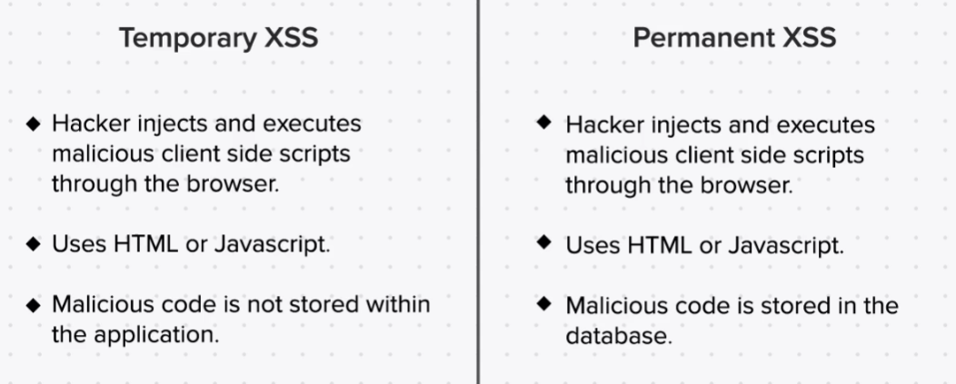

Q. What is temporary XSS?

The vulnerabilities that allows hackers to insert malicious codes into the HTML code of the browser are called as temporary XSS or reflected xss. This attack is called temporary as the injected attack is not stored within the application, rather it infects only those users who have access to these links.

Q. What is permanent XSS?

The vulnerabilities that allows hackers to inject and execute malicious client side scripts through the browser which gets permanently stored in the server are called as permanent XSS or stored XSS.

Q. What is an HTML injection?

When a hacker is not able to execute JavaScript using XSS, but still able to cause potential harm using HTML. This particular vulnerability is called as HTML injection which occurs due to improper output validation as the website without any proper sanitation attaches the user input to its own HTML code.